SOCIAL WORK RURAL CAMP REPORT 2021

PILOT STUDY:

The 2nd Semester students of The Department of Social Work, The Oxford College of Arts visited BS Doddi village, T Bekuppe Grama Panchayath, Kanakapura Taluk on 2nd October 2021 to do the Pilot Study, a preliminary study of rural community for organizing the Social Work Camp 2021 as per the MSW 2nd Semester Curriculum. The students had orientation of the village community by observation, home visit, interaction with key persons of the village to plan, analyse and decide on the feasibility of organizing the Camp in the given area and time with available resources and support.

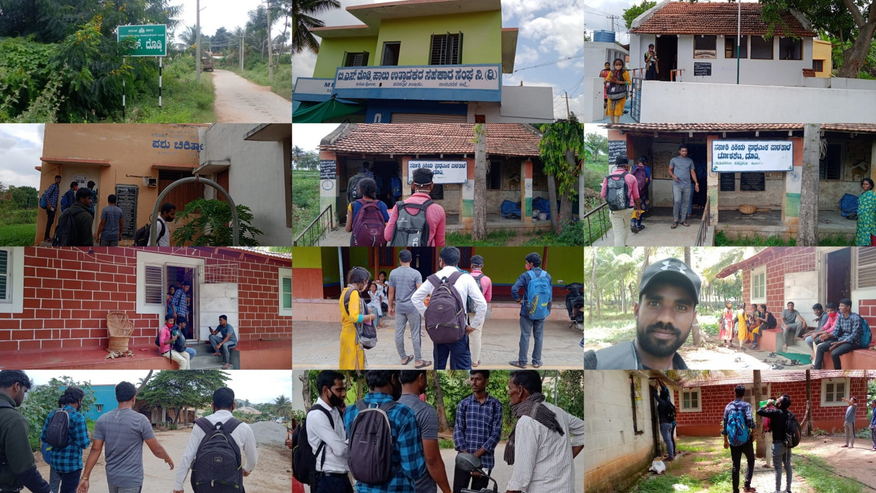

SOCIAL WORK RURAL CAMP:
The Department of Social Work, The Oxford College of Arts, Bangalore, organised the Rural Camp 2021 from 25 the October to 29th October 2021 at T Maniyambal Village, Kanakapur Tq, Ramanagara District.
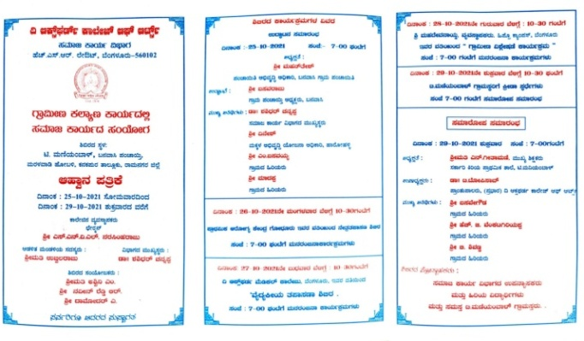
Every day the students had various scheduled activities from morning till night starting from Yoga and Exercises to equip the students mentally for whole day tasks and responsibilities, followed by Shramadan in the different selected areas of the village. The cultural programmes were held every evening by the students with the motto of infotainment to disseminate the worthwhile information through entertainment creating awareness on health, education, social problems, and ignorance. The daily camp evaluation for tracking the shortcomings to improvise the tasks in next days was conducted every night.
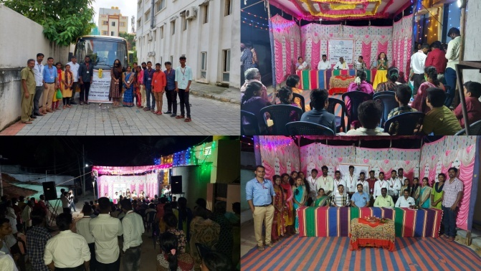
On 25th the inauguration programme of the camp was held at 7 pm. The Camp was inaugurated by Shri Basavaraju, the president of Banavasi Gram Panchayath and presided over by Mr Mahantesh, PDO, Banavasi Gram Panchayath.
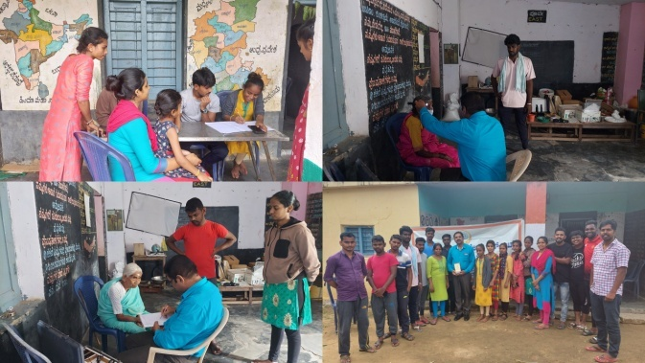
On 26th Eye Check Up camp was held at the Govt Primary School in the village by Primary Health Centre Godhur. The villagers utilised the camp by availing the service by doctors. The social work students volunteered very well in the camp by involving themselves in tasks such as inviting the villagers by visiting every household, bringing elders to camp site and guiding the beneficiaries of health camp about the medical prescriptions and next care plan to be made as directed by the doctor.
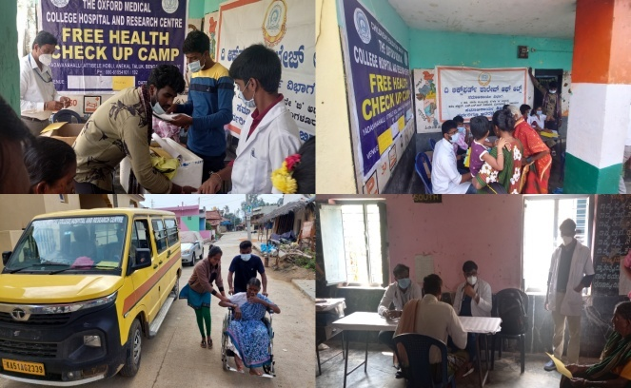
On 27th the General Health Camp was organised at the Govt. Primary School by The Oxford Medical College, Bangalore. The villagers attended the camp in huge number and made the organization of camp worthwhile. The students volunteered well in the organisation of health check up camp in intimating, registering and guiding the villagers to take up necessary care and medicines for better health.
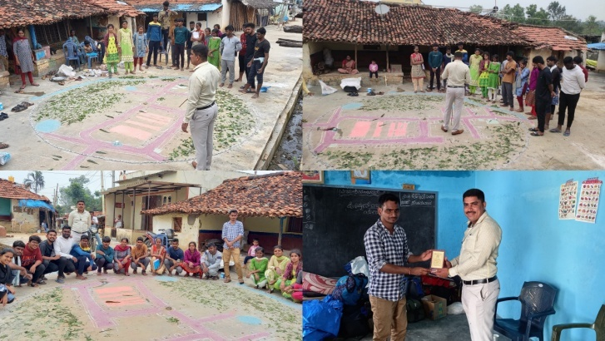
On 28th Participatory Rural Appraisal was held in the village to analyze the existing rural problems in the village and conscientise the villagers about the potential factors prevailing in the area which could help in problem solving process in the community. Mr Mahadeva Nayak, Manager, Hippo Campus the resource person for the programme coordinated and guided the students to activate the tasks of Participative Rural Appraisal system. The villagers actively participated in the pro-active think and act basis session
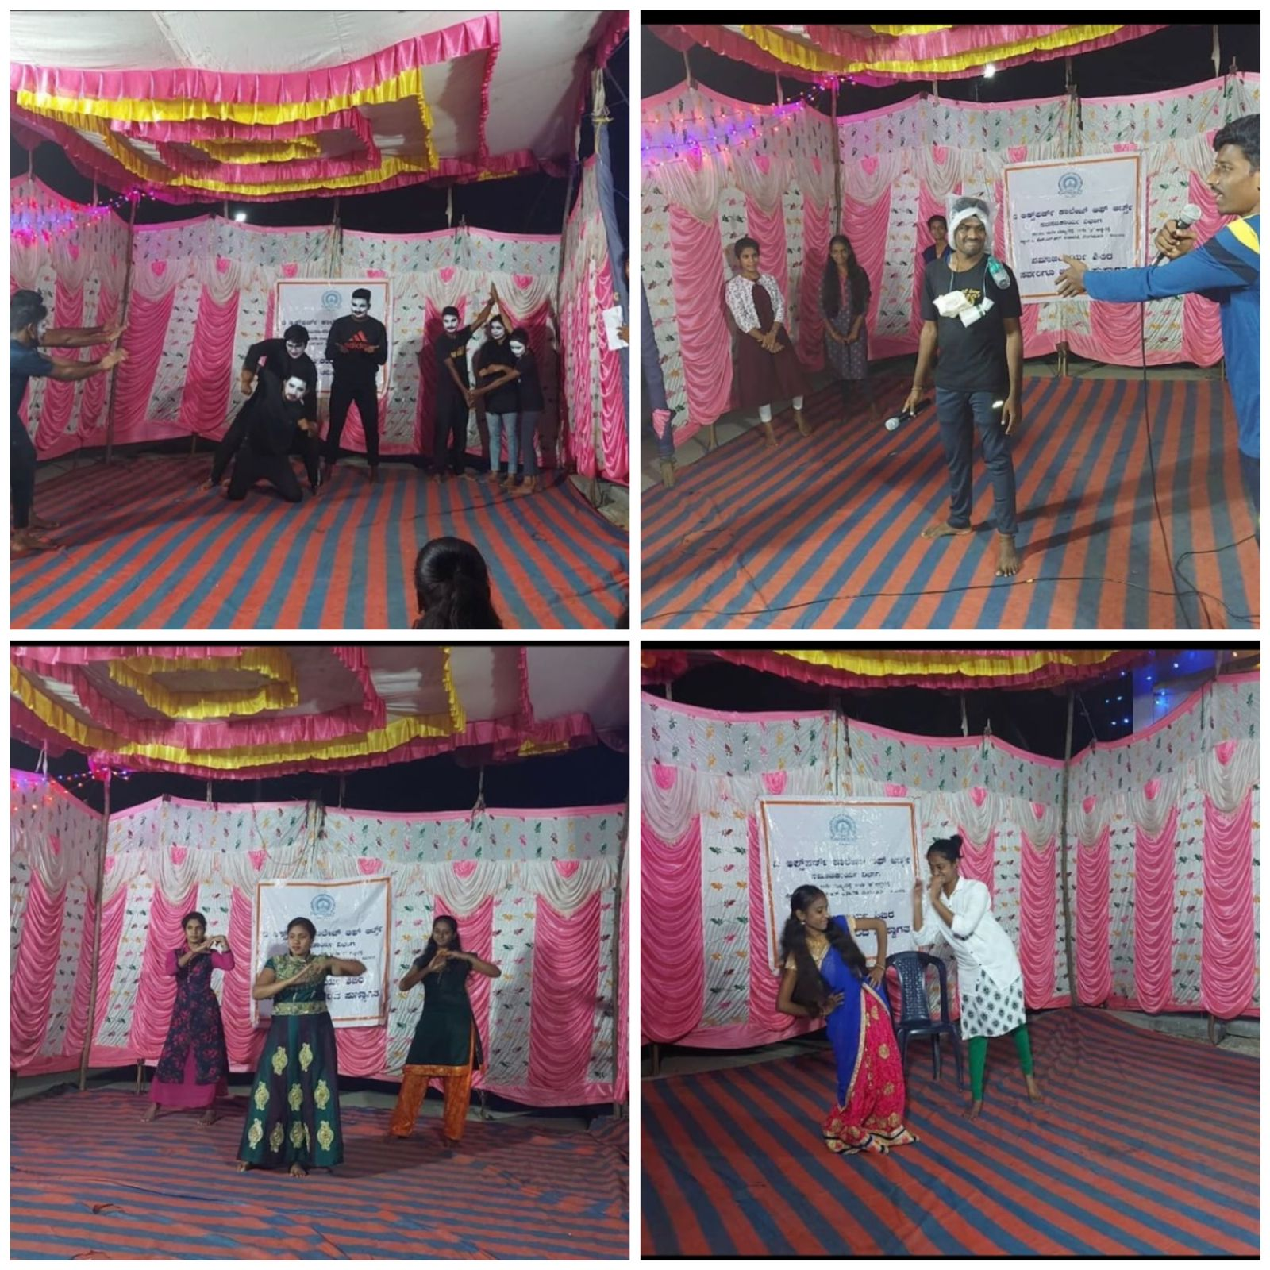
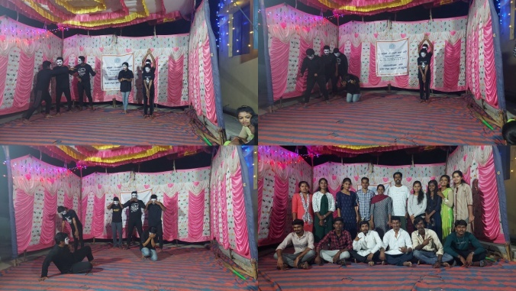

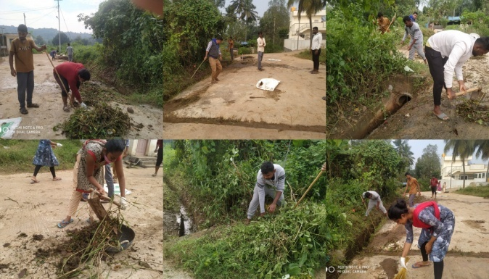
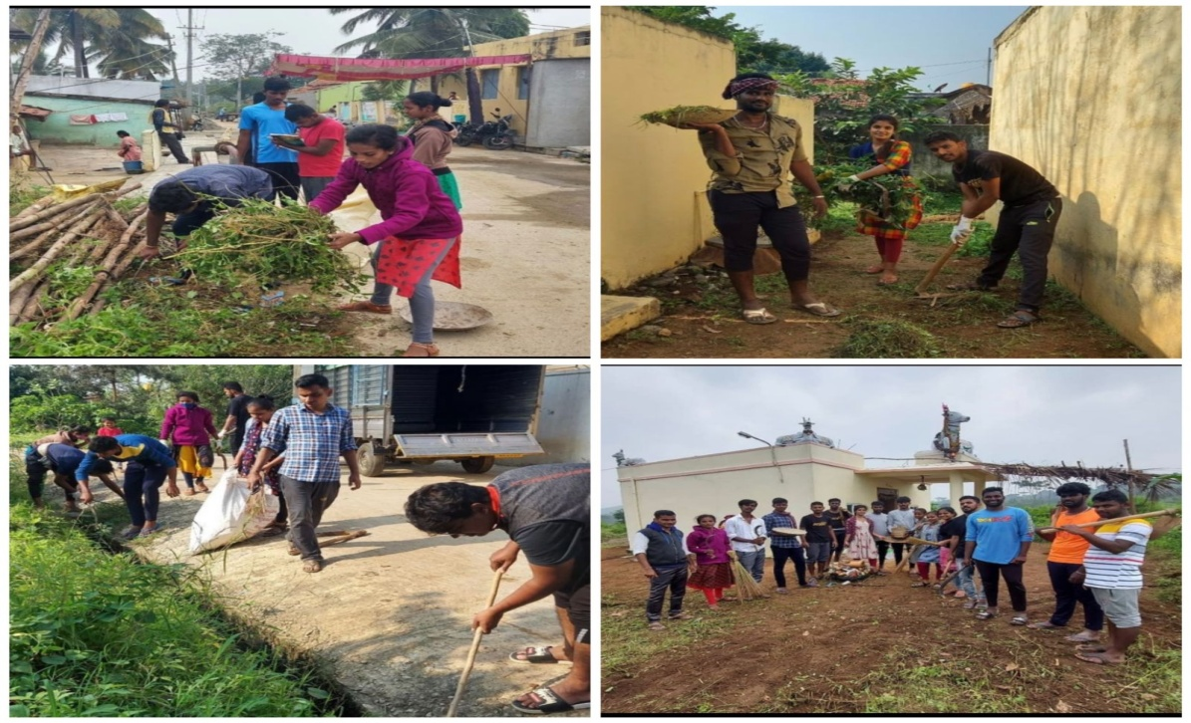
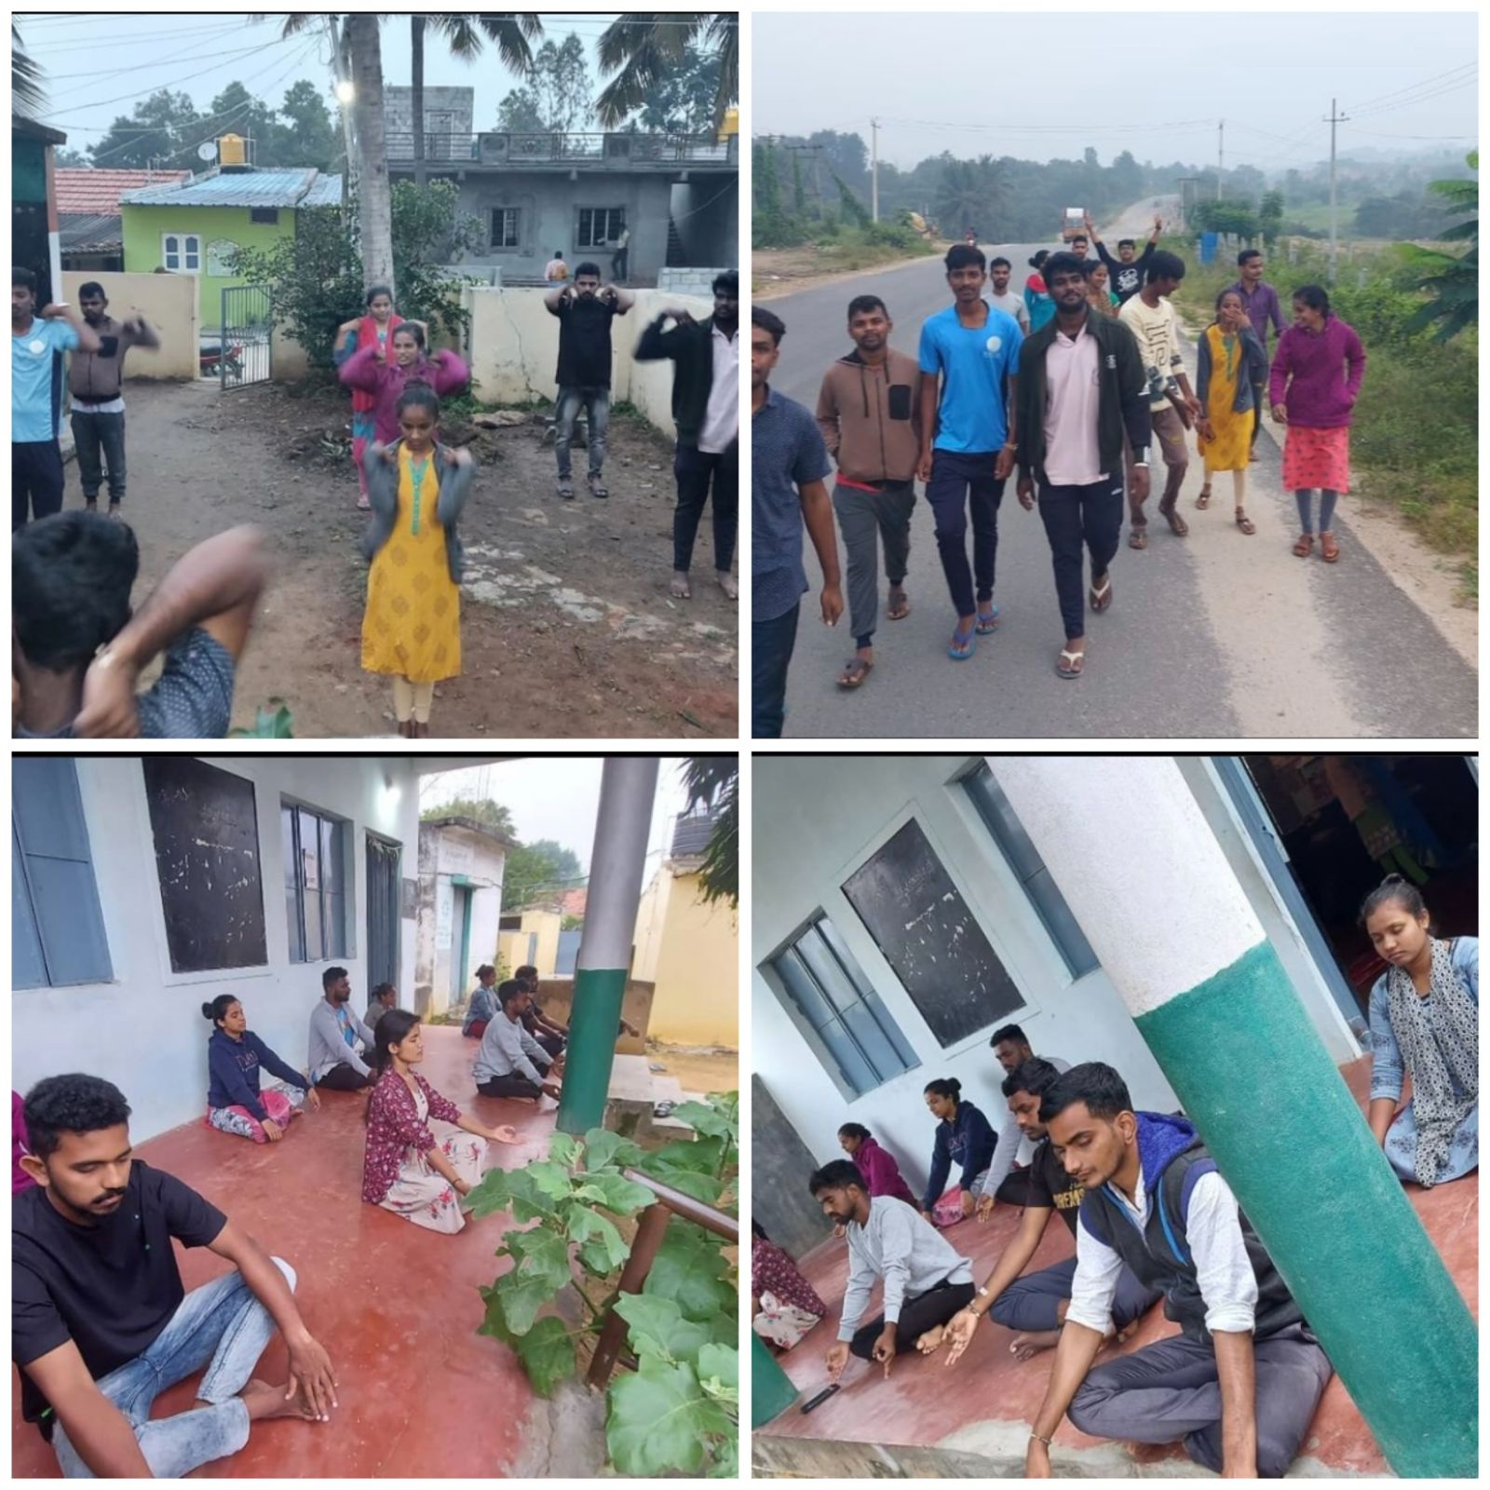
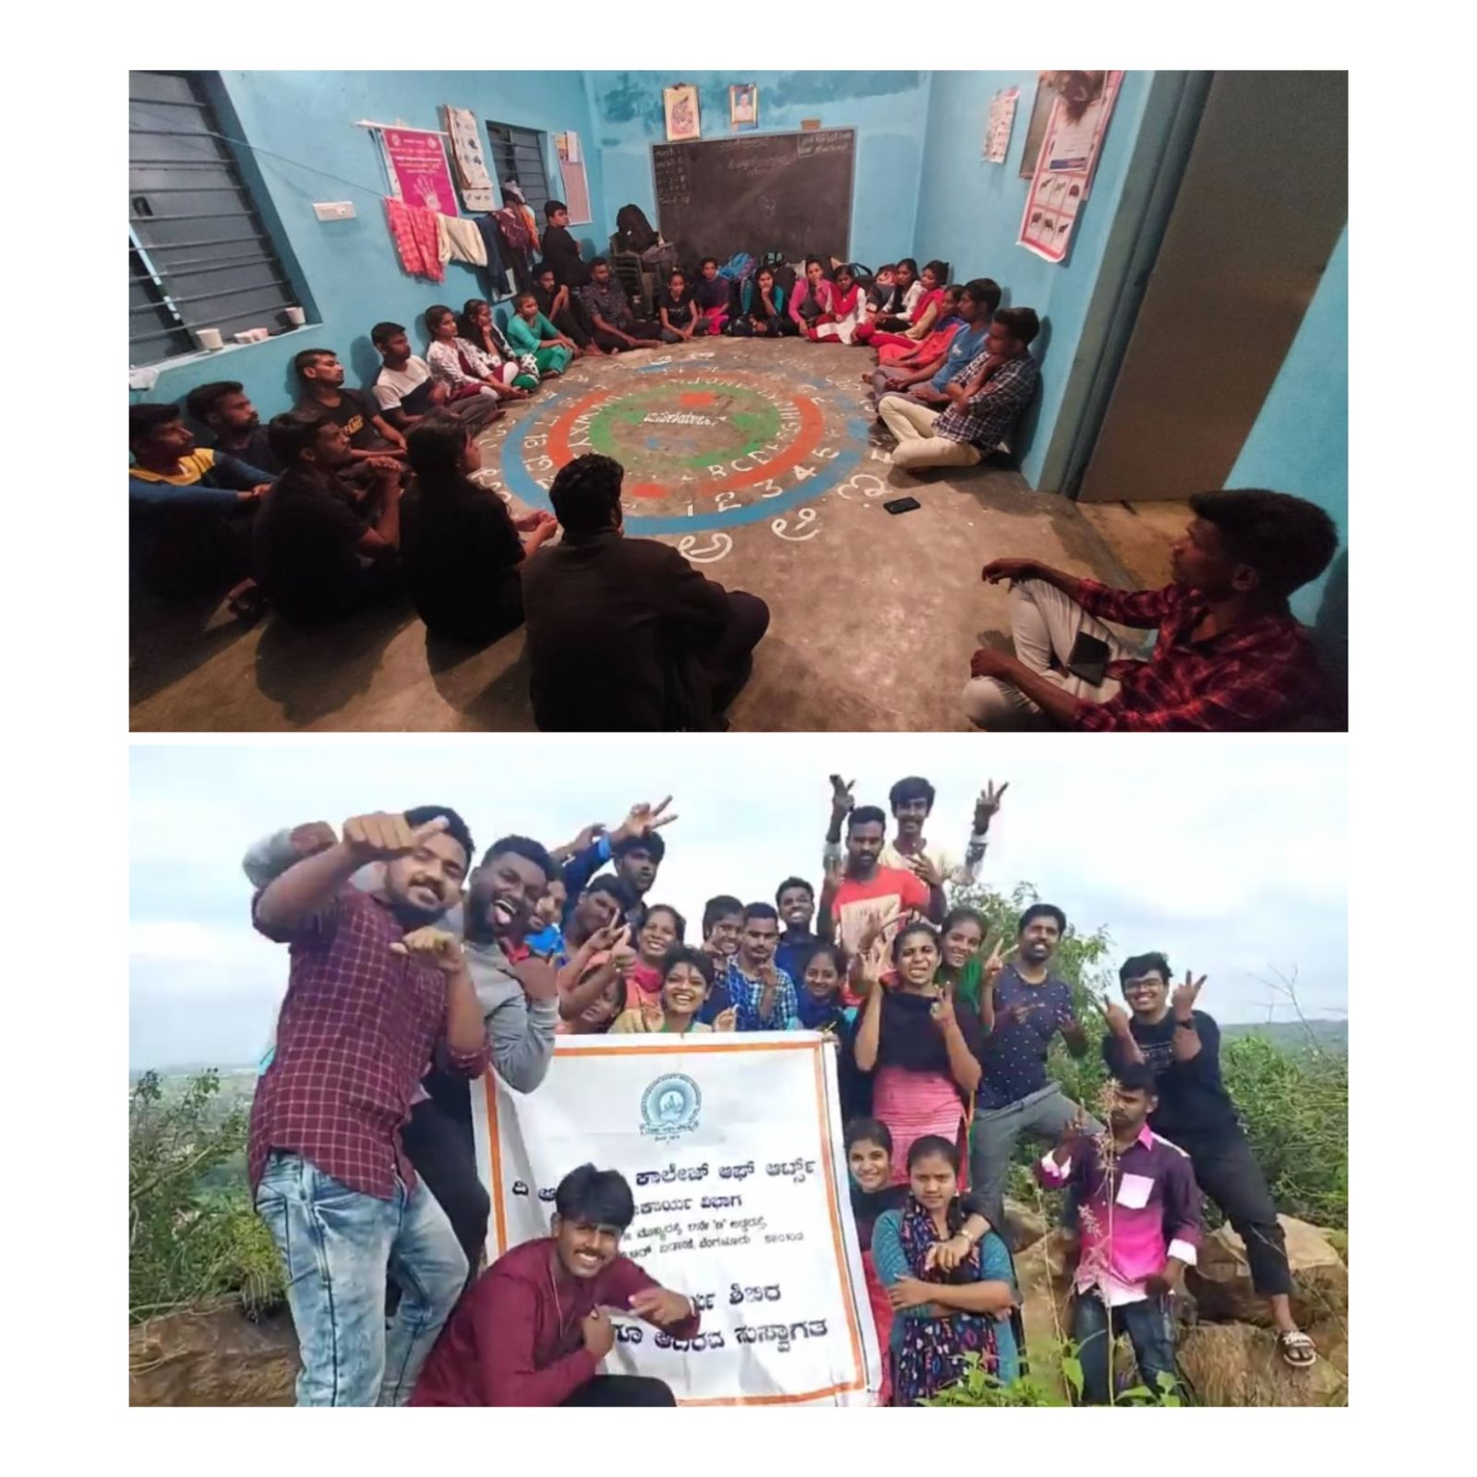
Due to sad demise of eminent Kannada Actor Mr. Puneeth Rajkumar formal valedictory function was called off on condolent protocol. As the Token of Gratitude, the mementos were handed over to the dignitaries who were active supporters of the Camp. The department of social work on behalf of the Oxford Educational Institutions, Management, Faculty, students expressed deep gratitude to the representatives, the people of the village who made the camp successful by providing the opportunity to conduct the camp and helping with material, food, financial support directly and indirectly with due respect and concerns.

